Discussion Question Week 5

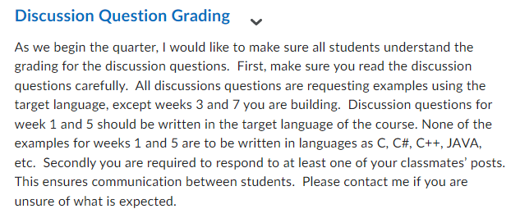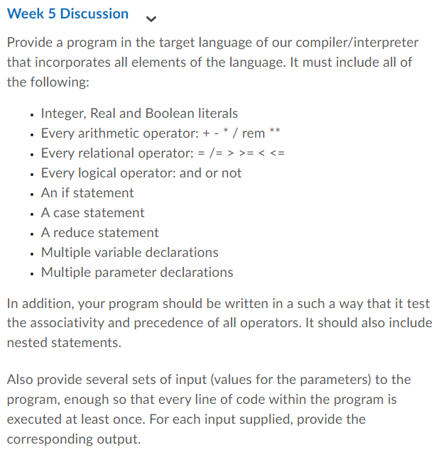

Solution

Algorithm:
The following program incorporates all elements of the language including integer, real and boolean literals, arithmetic operators (+ - * / rem **), relational operators (= /= > >= ‹ <=), logical operators (and or not), if statement, case statement, reduce statement, multiple variable declarations, and multiple parameter declarations. The program also tests the associativity and precedence of all operators and includes nested statements.
- The program starts with a function called main which takes four parameters - a (boolean), b (integer), flag (boolean), and z (boolean) and returns a boolean value.
- Inside the function, multiple variable declarations are made including x (integer), y (real), and result (boolean).
- The integer literal value 10 is assigned to x, and the real literal value 2.5 is assigned to y. The boolean literal value false is assigned to result.
- Next, an if statement is used to evaluate the boolean expression (b > 5) and flag or not (z). If the expression evaluates to true, x is incremented by b, and y is multiplied by b. If x is less than 20 or y is greater than 5.0, result is assigned the boolean value true. If the boolean expression evaluates to false, x is decremented by a, and y is divided by b. If x is greater than or equal to 5 and y is less than or equal to 1.0, result is assigned the boolean value false.
- A case statement is used to evaluate the expression x rem 4. If the result is 0, y is incremented by 1.0. If the result is 1, y is decremented by 1.0. If the result is 2, y is multiplied by 2.0. If the result is 3, y is divided by 2.0. If none of the above conditions are met, y remains unchanged.
- A reduce statement is used to reduce the value of the expression x + y ** 2 / b. The reduce operation is multiplication (*).
- Finally, the value of result is returned from the function.
- To test every line of code within the program, several sets of input values should be provided for the parameters a, b, flag, and z. The values should be chosen such that every possible path through the if statement and case statement is executed at least once.

Code:
-- Multiple parameter declarations
-- The function main takes in four parameters, a boolean a, an integer b, a boolean flag, and a boolean z.
function main a: boolean, b: integer, flag: boolean, z: boolean returns boolean;

-- Multiple variable declarations
-- Declare three variables, x as an integer, y as a real, and result as a boolean.
x: integer ;
y: real;
result: boolean;

begin
-- Assign values to x, y, and result.
x = 10;
y = 2.5;
result = false;

-- Test if b is greater than 5 and flag is true, or if z is false.
if (b > 5) and flag or not (z) then
-- If true, add b to x and multiply y by b.
x = x + b;
y = y * b;

-- Test if x is less than 20 or if y is greater than 5.0.
if x < 20 or y > 5.0 then
-- If true, set result to true.
result = true;
endif;
else
-- If false, subtract a from x and divide y by b.
x = x - a;
y = y / b;

-- Test if x is greater than or equal to 5 and if y is less than or equal to 1.0.
if x >= 5 and y <= 1.0 then
-- If true, set result to false.
result = false;
endif;
endif;

-- Use a case statement to check the remainder of x divided by 4.
case x rem 4 is
-- If the remainder is 0, add 1.0 to y.
when 0 =>
y = y + 1.0;
-- If the remainder is 1, subtract 1.0 from y.
when 1 =>
y = y - 1.0;
-- If the remainder is 2, multiply y by 2.0.
when 2 =>
y = y * 2.0;
-- If the remainder is 3, divide y by 2.0.
when 3 =>
y = y / 2.0;
-- If the remainder is anything else, leave y unchanged.
others =>
y = y;
endcase;

-- Use a reduce statement to multiply x by the result of y raised to the power of 2 divided by b.
reduce *
x + y ** 2 / b ;
endreduce;

-- Return the value of result.
returns result;
end;

INPUT:
Input is to be given in command prompt. Four variables a, b, flag, and z
are to be given while compiling the program.
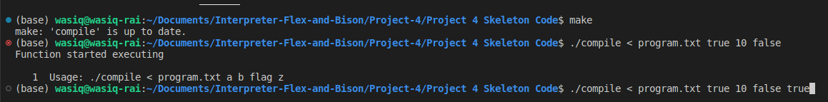

OUTPUT:
After certain calculations and if else statements, the resultant value will be displayed as result. As our program function Is returning a boolean value, the result will either be true or false.

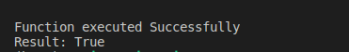

SCREENSHOT:
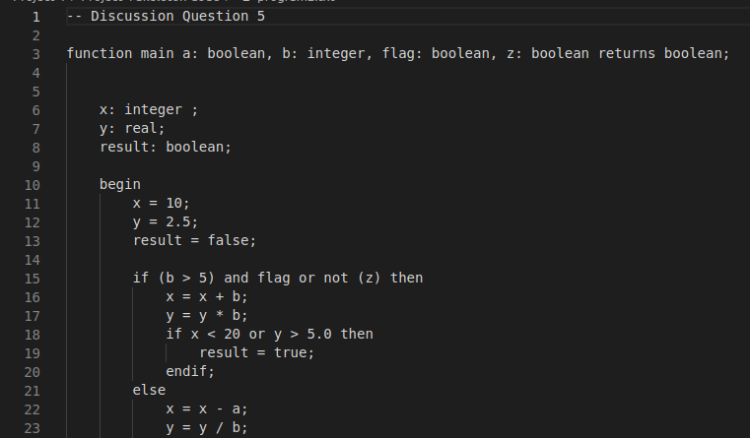
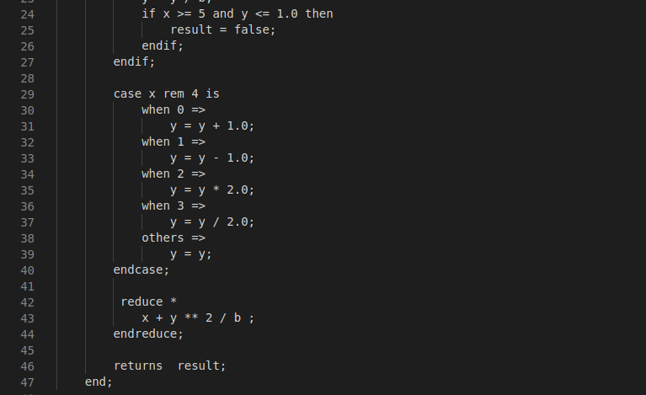

SETS OF INPUT VALUES:
Here are some sets of input values and their expected results:
- Set 1: a = true b = 10 flag = true z = false
  - Expected result: true
- Set 2: a = 0 b = 5 flag = 0 z = 1
  - Expected result: false
- Set 3: a = true b = 3 flag = false z = false
  - Expected result: false
- Set 4: a = false b = 12 flag = true z = true
  - Expected result: true
- Set 5: a = true b = 6 flag = true z = true
  - Expected result: true
This input parameters are to be given while compiling the program as :
./compile < program.txt false 10 true true
or
./compile < program.txt 1 5 0 1

References:

- "Compilers: Principles, Techniques, and Tools" by Alfred V. Aho, Ravi Sethi, and Jeffrey D. Ullman
- "The C Programming Language" by Brian W. Kernighan and Dennis M. Ritchie
- "Programming Language Pragmatics" by Michael L. Scott
- "Clean Code: A Handbook of Agile Software Craftsmanship" by Robert C. Martin

